PM518a Project

Date Assigned: Mar 24 2021

Date Due: Apr 28 2021

The STATA dataset “**framingham_2021**” provides data on participants in the Framingham cohort study.

**Background:** The Framingham cohort study is a long-term prospective study, examining determinants of cardiovascular disease in a free-living population of residents of the city of Framingham, Massachusetts. The study began in 1948, enrolling 5209 subjects. Cardiovascular disease outcomes were identified through routine surveillance of area hospitals, participant reports, and death certificates.

**Dataset:** All subjects began follow-up for incident outcomes at the baseline exam. Subjects with prevalent coronary heart disease (at the baseline exam) were excluded from this dataset. The primary outcome of interest in this analysis is time to first nonfatal myocardial infarction or coronary death.

**Objective:** The investigators want to identify modifiable risk factors (i.e., factors that one might change through lifestyle or use of medications) for coronary heart disease. In the dataset, these modifiable risk factors include blood pressure, cholesterol, BMI, smoking, and diabetes. Non-modifiable variables in the dataset that might be related to coronary heart disease risk include age and sex, with education as an additional variable for possible adjustment.

The dataset contains 11 variables:

|  |  |  |
| --- | --- | --- |
| Variable | Description | Codes |
| randid | Subject ID |  |
| sex | Participant sex | 1=Male  2=Female |
| age | Age at baseline examination |  |
| sysbp | Systolic blood pressure (mmHg) |  |
| cursmoke | Current cigarette smoker | 0 = no  1 = yes |
| educ | Education | 1 = 0-11 years  2 = High school graduate  3 = Some college  4 = College degree |
| totchol | Total cholesterol (mg/dL) |  |
| bmi | Body mass index (kg/m2) |  |
| diabetes | Diabetes | 0 = no  1 = yes |
| mi_chd | Hospitalized myocardial infarction or fatal coronary heart disease | 0 = no  1 = yes |
| lasttime | Time since baseline exam (years).  Equal to time of MI/CHD death for mi_fchd=1.  Equal to time last observed disease free for mi_fchd=0. |  |

General instructions:

1. This project is to be completed alone. Any evidence of sharing of programs, output, text will result in an F in the course and will be referred to student judicial affairs
2. The project should be turned in on Blackboard by the due date.
3. Turn in two project files:
   1. Responses to the questions below, which may include text, tables and figures.  
      Title this file “pm518aproject_text_lastname_firstname”  
      **This document should be no longer than 15 pages, using Arial Font 11. Any documents longer than 15 pages will not be accepted.**
   2. Your stata smcl file(s), organized by the question (e.g. 1, 2a, 2b, etc.)  
      Title this file “pm518aproject_smcl_lastname_firstname”  
      **Suggestion**: When you have completed your responses and have an error-free working program, run the program, saving to the smcl file referenced above. At the top of your program, insert the following command: log using “pm518aproject_smcl_xxx_xxx” (inserting your last name and first name). This will save the log to an smcl file in your working directory.

**Assignment:** Develop a multivariable model for modifiable risk factors for coronary heart disease (non-fatal myocardial infarction or fatal coronary death). Unless otherwise specified, confine your analyses to main effects only (do not model interactions unless requested or needed to meet modeling assumptions).

1. Explore your data: Examine the distributions of your independent variables.
   1. Develop a descriptive table, with separate columns for subjects with and without MI/CHD events. The table should be of publication quality.

**Descriptive Statistics for Independent Variables**

|  |  |  |  |  |  |  |
| --- | --- | --- | --- | --- | --- | --- |
| **mi_chd = 0** | **N** | | **mean** | **sd** | **min** | **max** |
| Total Cholesterol (mg/dL) | | 3608 | 234.337 | 43.568 | 113 | 696 |
| Body Mass Index (kg/m2) | | 3608 | 25.621 | 4.047 | 15.54 | 56.8 |
| Age at Baseline Examination | | 3608 | 49.14 | 8.517 | 32 | 69 |
| Systolic Blood Pressure (mmHg) | | 3608 | 130.72 | 21.024 | 83.5 | 248 |

**mi_chd = 1**

|  |  |  |  |  |  |  |
| --- | --- | --- | --- | --- | --- | --- |
| Total Cholesterol (mg/dL) | 604 | 251.831 | 47.835 | 149 | 600 | |
| Body Mass Index (kg/m2) | 604 | 26.872 | 4.072 | 15.96 | 51.28 | |
| Age at Baseline Examination | 604 | 51.969 | 8.396 | 34 | 70 | |
| Systolic Blood Pressure (mmHg) | 604 | 141.579 | 24.914 | 83.5 | 295 | |
| **Tabulation of sex when mi_chd is 0**   |  |  |  |  | | --- | --- | --- | --- | | **Participant Sex** | **Freq.** | **Percent** | **Cum.** | | Male | 1424 | 39.47 | 39.47 | | Female | 2184 | 60.53 | 100.00 | | Total | 3608 | 100.00 |  | |  | | | | | **Tabulation of educ when mi_chd is 0**   |  |  |  |  | | --- | --- | --- | --- | | **Education** | **Freq.** | **Percent** | **Cum.** | | 0-11 years | 1434 | 39.75 | 39.75 | | High School | 1171 | 32.46 | 72.20 | | Some college | 606 | 16.80 | 89.00 | | College degree | 397 | 11.00 | 100.00 | | Total | 3608 | 100.00 |  | | | | | |   **Tabulation of cursmoke when mi_chd is 0**   |  |  |  |  | | --- | --- | --- | --- | | **Current Cigarette Smoker** | **Freq.** | **Percent** | **Cum.** | | No | 1862 | 51.61 | 51.61 | | Yes | 1746 | 48.39 | 100.00 | | Total | 3608 | 100.00 |  | |  | | | |   **Tabulation of diabetes when mi_chd is 0**   |  |  |  |  | | --- | --- | --- | --- | | **Diabetes** | **Freq.** | **Percent** | **Cum.** | | No | 3540 | 98.12 | 98.12 | | Yes | 68 | 1.88 | 100.00 | | Total | 3608 | 100.00 |  | |  | | | |   **Tabulation of sex when mi_chd is 1**   |  |  |  |  | | --- | --- | --- | --- | | **Participant Sex** | **Freq.** | **Percent** | **Cum.** | | Male | 391 | 64.74 | 64.74 | | Female | 213 | 35.26 | 100.00 | | Total | 604 | 100.00 |  | |  | | | |   **Tabulation of educ when mi_chd is 1**   |  |  |  |  | | --- | --- | --- | --- | | **Education** | **Freq.** | **Percent** | **Cum.** | | 0-11 years | 273 | 45.20 | 45.20 | | High school graduate | 175 | 28.97 | 74.17 | | Some college | 80 | 13.25 | 87.42 | | College degree | 76 | 12.58 | 100.00 | | Total | 604 | 100.00 |  | |  | | | |   **Tabulation of cursmoke when mi_chd is 1**   |  |  |  |  | | --- | --- | --- | --- | | **Current Cigarette Smoker** | **Freq.** | **Percent** | **Cum.** | | No | 269 | 44.54 | 44.54 | | Yes | 335 | 55.46 | 100.00 | | Total | 604 | 100.00 |  | |  | | | |   **Tabulation of diabetes when mi_chd is 1**   |  |  |  |  | | --- | --- | --- | --- | | **Diabetes** | **Freq.** | **Percent** | **Cum.** | | No | 566 | 93.71 | 93.71 | | Yes | 38 | 6.29 | 100.00 | | Total | 604 | 100.00 |  | | | | | | |

* 1. BRIEFLY summarize your table.  
     The descriptive statistics table shows that those with MI/CHD event have a higher mean total cholesterol, mean body mass index, mean age, and mean systolic blood pressure, although a t-test is required to confirm if the differences are statistically significant. The table also shows that those subjects with MI/CHD event have higher standard deviation in the independent variables of interest compared to those without MI/CHD event, possibly because those with MI/CHD event have a larger sample size compared to those without. The frequency tables show that subjects with MI/CHD event proportionally tend to be male, have less education, currently smoke cigarettes, and have diabetes. Although further statistical tests such as Z test need to be performed to confirm the differences in proportions are statistically significant.

1. Given the growing prevalence of diabetes in industrialized nations, the investigators are particularly interested in the contribution of diabetes to MI/CHD risk.  
   1. Provide a Kaplan-Meier survival curve, comparing persons with and without diabetes.  
      
   2. In each group (diabetics and non-diabetics), give estimates of 5-, 10-, 15-, and 20-year cumulative survival, along with 95% confidence intervals.  
      Non-diabetics:

5-year cumulative survival is .9803 (95% CI: .9755, .9841)

10-year cumulative survival is .9562 (95% CI: .9494, .9621)

15-year cumulative survival is .9199 (95% CI: .9109, .9280)

20-year cumulative survival is .8827 (95% CI: .8719, .8926)

Diabetics:

5-year: .9294 (95% CI: .8575, .9657)

10-year: .8540 (95% CI: .7656, .9109)

15-year: .7226 (95% CI: .6166, .8040)

20-year: .6056 (95% CI: .4884, .7040)

* 1. Test for differences in survival using an appropriate test.  
     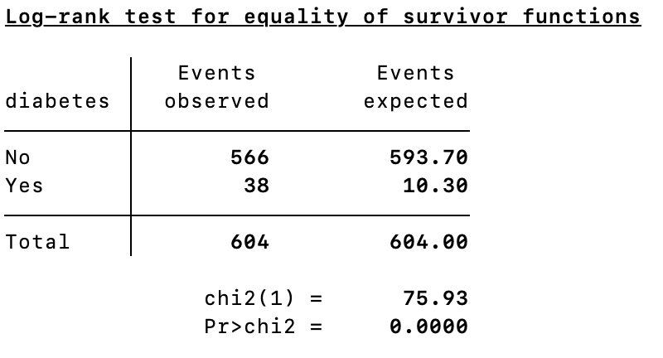
  2. Write a conclusion of no more than 3 sentences.  
     Log-rank test has a significant p-value, there is a statistically significant difference in survival between those subjects with and without diabetes. Subjects without diabetes have statistically significantly higher cumulative survival probability at the 5-, 10-, 15- and 20-year marks. Kaplan-Meier survival curve for those with diabetes descends quicker than those without.

1. Use Cox proportional hazards regression to develop a multivariable model for the MI/CHD hazard rate. As stated above, particular interest lies in a model for the **modifiable r**isk factors. You should additionally consider age, sex, and education as possible confounders. Follow the steps below.  
   1. Use martingale residuals to evaluate the linearity of the continuous independent variables.   
      1. Provide lowess plots of martingale residuals against each continuous variable.   
          





* + 1. Perform transformations of continuous variables if needed to achieve linearity, or consider an alternative modeling (e.g., as categorical variable).  
       No transformations are needed since all three plots look fairly linear.
    2. Center your continuous variables around their mean for further modeling.  
       See smcl file for coding. Variables c_sysbp, c_totchol, c_bmi will be used for further modeling in place of sysbp, totchol, bmi.
  1. Test the univariate association of each of the variables with the MI/CHD hazard rate.  
     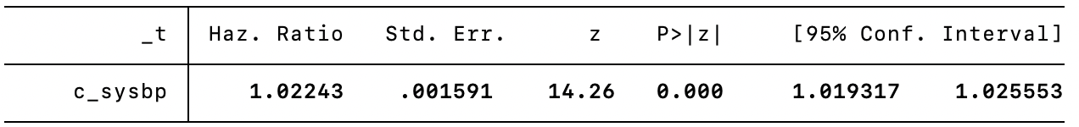

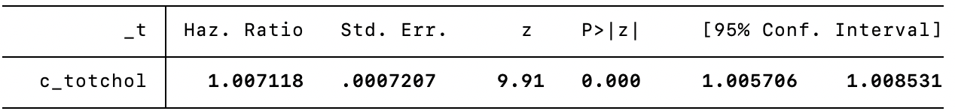

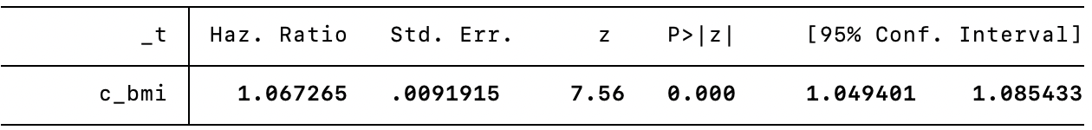

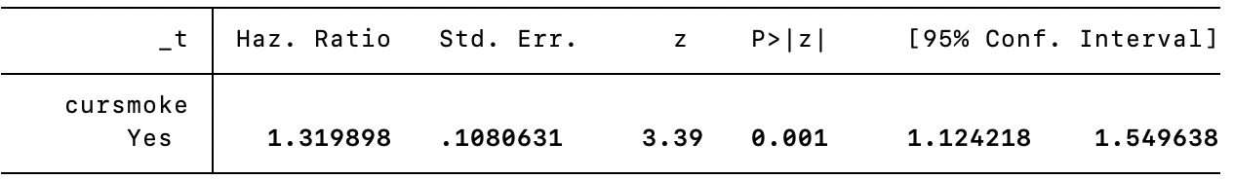

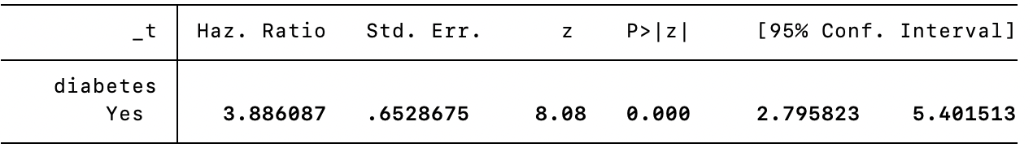

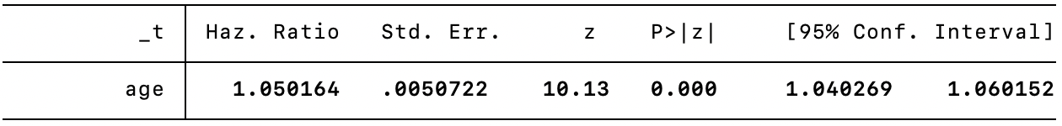

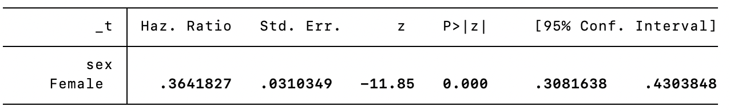

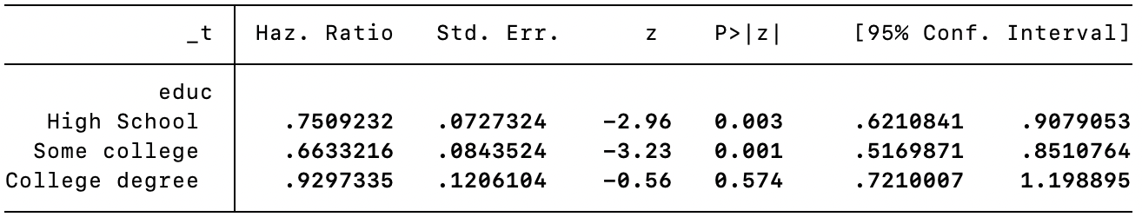

All univariate associations have significant p-values (<.05). Each of the above variable tested is a statistically significant variable in univariate models for MI/CHD survival analysis.

* 1. Develop a multivariable main effects model with the modifiable risk factors. The final model should include:  
     1. Modifiable risk factors that are statistically significant in the multivariate model.

Base model include covariates sysbp, totchol, bmi, cursmoke, and diabetes.   
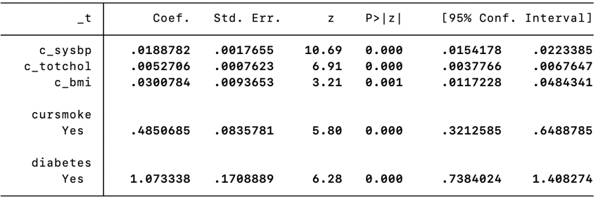

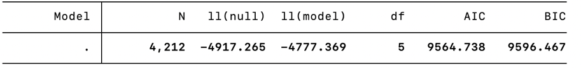

* + 1. Age, sex, and education if they are confounders of any of the modifiable risk factor associations.  
       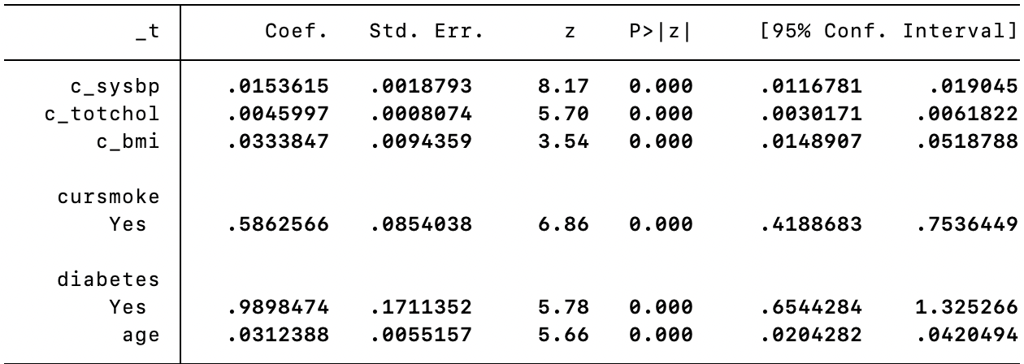

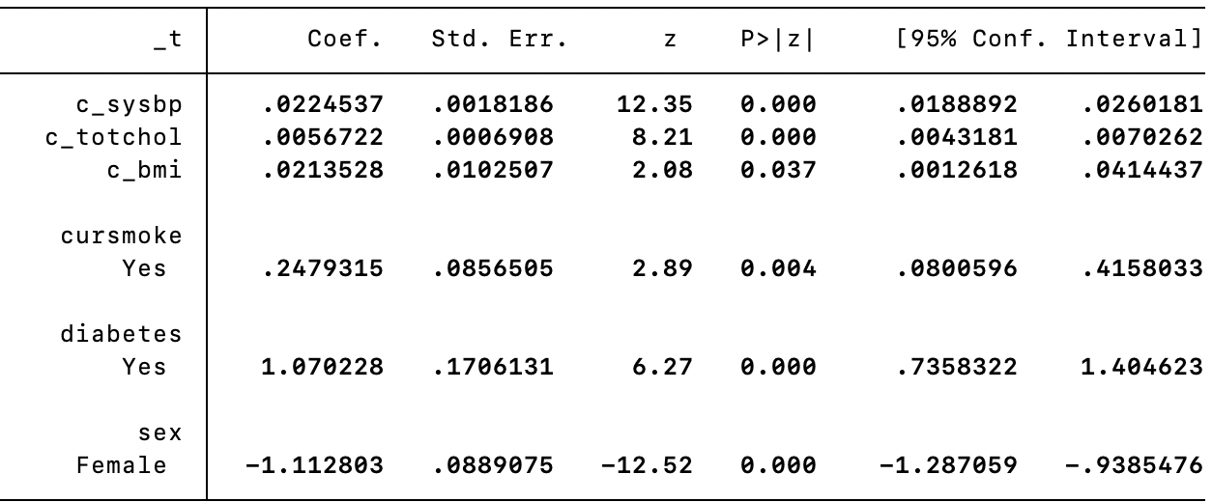

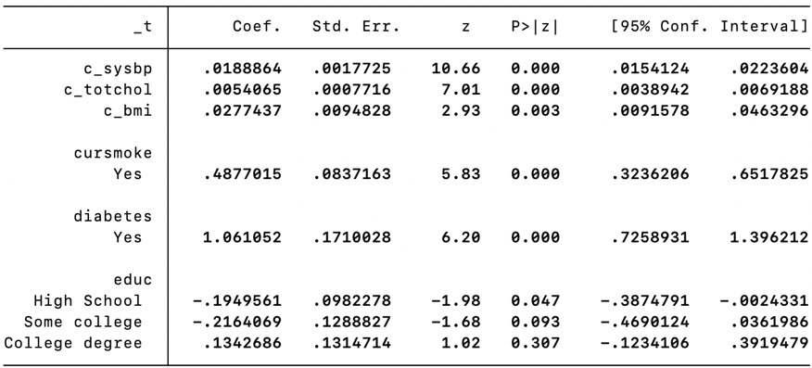

10% change for coefficient is used to determine confounders among age, sex and education. Age and sex were found to be confounders, education was not. Age and sex were included in the updated model. The updated model has lower AIC and BIC compared to base model, indicating better fit.

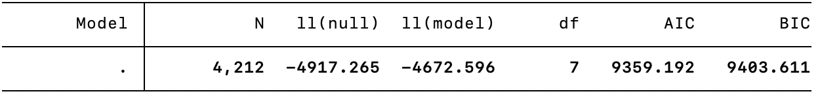

* 1. Test the proportional hazards assumption for your multivariable model.   
     1. Identify any variables that do not meet proportional hazards. If needed, modify your modeling to deal with this issue.  
        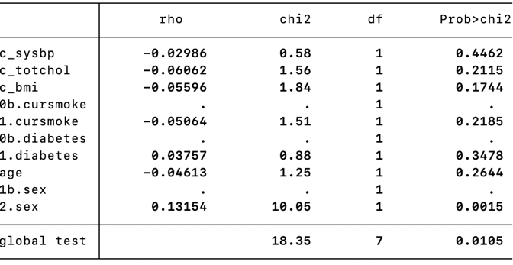



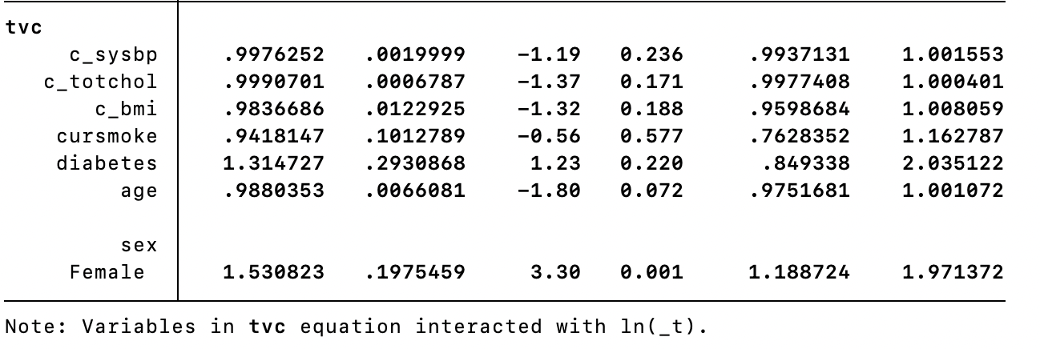





Sex is found to be not meeting proportional hazards assumption, we do stratified analysis as a result. Lower AIC and BIC indicate better fit compared to base model.

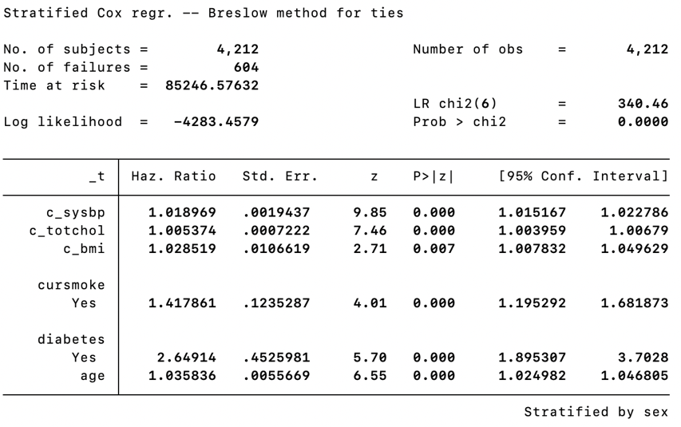

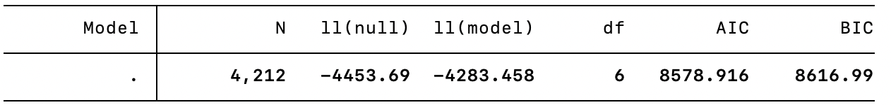

* 1. Complete model diagnostics on your final multivariable model.  
     





Three methods for model diagnostics were used: cox-snell residuals, influential observations, and likelihood displacement. The model seems to be a good fit, but observation with subject ID 7411567 seems to be an influential observation.

* 1. Make a table of your univariate and multivariate associations, including HRs, 95% confidence intervals and p-values. This table must be of publication quality.  
     **Regression Results for Multivariate Model Stratified by Sex**

|  |  |  |  |  |  |  |  |  |  |  |  |
| --- | --- | --- | --- | --- | --- | --- | --- | --- | --- | --- | --- |
| _t | Haz. Ratio | | St.Err. | t-value | | p-value | [95% Conf | | Interval] | | Sig |
| c_sysbp | 1.019 | | .002 | 9.85 | | 0 | 1.015 | | 1.023 | | *** |
| c_totchol | 1.005 | | .001 | 7.46 | | 0 | 1.004 | | 1.007 | | *** |
| c_bmi | 1.029 | | .011 | 2.71 | | .007 | 1.008 | | 1.05 | | *** |
| 0b.cursmoke | 1 | | . | . | | . | . | | . | |  |
| 1.cursmoke | 1.418 | | .124 | 4.01 | | 0 | 1.195 | | 1.682 | | *** |
| 0b.diabetes | 1 | | . | . | | . | . | | . | |  |
| 1.diabetes | 2.649 | | .453 | 5.70 | | 0 | 1.895 | | 3.703 | | *** |
| age | 1.036 | | .006 | 6.55 | | 0 | 1.025 | | 1.047 | | *** |
|  | | | | | | | | | | | |
| Mean dependent var | | 20.239 | | | SD dependent var | | | 6.273 | |
| Pseudo r-squared | | 0.038 | | | Number of obs | | | 4212.000 | |
| Chi-square | | 340.464 | | | Prob > chi2 | | | 0.000 | |
| Akaike crit. (AIC) | | 8578.916 | | | Bayesian crit. (BIC) | | | 8616.990 | |
| *\*\*\* p<.01, ** p<.05, * p<.1* | | | | | | | | | | | |

**Univariate Model of Systolic Blood Pressure Stratified by Sex**

|  |  |  |  |  |  |  |  |  |  |  |  |
| --- | --- | --- | --- | --- | --- | --- | --- | --- | --- | --- | --- |
| _t | Haz. Ratio | | St.Err. | t-value | | p-value | [95% Conf | | Interval] | | Sig |
| c_sysbp | 1.026 | | .002 | 15.65 | | 0 | 1.023 | | 1.029 | | *** |
|  | | | | | | | | | | | |
| Mean dependent var | | 20.239 | | | SD dependent var | | | 6.273 | |
| Pseudo r-squared | | 0.023 | | | Number of obs | | | 4212.000 | |
| Chi-square | | 204.720 | | | Prob > chi2 | | | 0.000 | |
| Akaike crit. (AIC) | | 8704.660 | | | Bayesian crit. (BIC) | | | 8711.005 | |
| *\*\*\* p<.01, ** p<.05, * p<.1* | | | | | | | | | | | |

**Univariate Model of Total Cholesterol Stratified by Sex**

|  |  |  |  |  |  |  |  |  |  |  |  |
| --- | --- | --- | --- | --- | --- | --- | --- | --- | --- | --- | --- |
| _t | Haz. Ratio | | St.Err. | t-value | | p-value | [95% Conf | | Interval] | | Sig |
| c_totchol | 1.007 | | .001 | 11.24 | | 0 | 1.006 | | 1.009 | | *** |
|  | | | | | | | | | | | |
| Mean dependent var | | 20.239 | | | SD dependent var | | | 6.273 | |
| Pseudo r-squared | | 0.010 | | | Number of obs | | | 4212.000 | |
| Chi-square | | 89.187 | | | Prob > chi2 | | | 0.000 | |
| Akaike crit. (AIC) | | 8820.193 | | | Bayesian crit. (BIC) | | | 8826.538 | |
| *\*\*\* p<.01, ** p<.05, * p<.1* | | | | | | | | | | | |

**Univariate Model of Body Mass Index Stratified by Sex**

|  |  |  |  |  |  |  |  |  |  |  |  |
| --- | --- | --- | --- | --- | --- | --- | --- | --- | --- | --- | --- |
| _t | Haz. Ratio | | St.Err. | t-value | | p-value | [95% Conf | | Interval] | | Sig |
| c_bmi | 1.067 | | .01 | 6.76 | | 0 | 1.047 | | 1.087 | | *** |
|  | | | | | | | | | | | |
| Mean dependent var | | 20.239 | | | SD dependent var | | | 6.273 | |
| Pseudo r-squared | | 0.005 | | | Number of obs | | | 4212.000 | |
| Chi-square | | 41.388 | | | Prob > chi2 | | | 0.000 | |
| Akaike crit. (AIC) | | 8867.992 | | | Bayesian crit. (BIC) | | | 8874.337 | |
| *\*\*\* p<.01, ** p<.05, * p<.1* | | | | | | | | | | | |

**Univariate Model of Current Smoking Stratified by Sex**

|  |  |  |  |  |  |  |  |  |  |  |  |
| --- | --- | --- | --- | --- | --- | --- | --- | --- | --- | --- | --- |
| _t | Haz. Ratio | | St.Err. | t-value | | p-value | [95% Conf | | Interval] | | Sig |
| 0b.cursmoke | 1 | | . | . | | . | . | | . | |  |
| 1.cursmoke | 1.098 | | .091 | 1.13 | | .26 | .933 | | 1.293 | |  |
|  | | | | | | | | | | | |
| Mean dependent var | | 20.239 | | | SD dependent var | | | 6.273 | |
| Pseudo r-squared | | 0.000 | | | Number of obs | | | 4212.000 | |
| Chi-square | | 1.273 | | | Prob > chi2 | | | 0.259 | |
| Akaike crit. (AIC) | | 8908.107 | | | Bayesian crit. (BIC) | | | 8914.452 | |
| *\*\*\* p<.01, ** p<.05, * p<.1* | | | | | | | | | | | |

**Univariate Model of Diabetes Stratified by Sex**

|  |  |  |  |  |  |  |  |  |  |  |  |
| --- | --- | --- | --- | --- | --- | --- | --- | --- | --- | --- | --- |
| _t | Haz. Ratio | | St.Err. | t-value | | p-value | [95% Conf | | Interval] | | Sig |
| 0b.diabetes | 1 | | . | . | | . | . | | . | |  |
| 1.diabetes | 3.667 | | .617 | 7.73 | | 0 | 2.637 | | 5.098 | | *** |
|  | | | | | | | | | | | |
| Mean dependent var | | 20.239 | | | SD dependent var | | | 6.273 | |
| Pseudo r-squared | | 0.005 | | | Number of obs | | | 4212.000 | |
| Chi-square | | 42.032 | | | Prob > chi2 | | | 0.000 | |
| Akaike crit. (AIC) | | 8867.348 | | | Bayesian crit. (BIC) | | | 8873.693 | |
| *\*\*\* p<.01, ** p<.05, * p<.1* | | | | | | | | | | | |

**Univariate Model of Age Stratified by Sex**

|  |  |  |  |  |  |  |  |  |  |  |  |
| --- | --- | --- | --- | --- | --- | --- | --- | --- | --- | --- | --- |
| _t | Haz. Ratio | | St.Err. | t-value | | p-value | [95% Conf | | Interval] | | Sig |
| age | 1.054 | | .005 | 10.82 | | 0 | 1.044 | | 1.064 | | *** |
|  | | | | | | | | | | | |
| Mean dependent var | | 20.239 | | | SD dependent var | | | 6.273 | |
| Pseudo r-squared | | 0.013 | | | Number of obs | | | 4212.000 | |
| Chi-square | | 117.022 | | | Prob > chi2 | | | 0.000 | |
| Akaike crit. (AIC) | | 8792.357 | | | Bayesian crit. (BIC) | | | 8798.703 | |
| *\*\*\* p<.01, ** p<.05, * p<.1* | | | | | | | | | | | |

* 1. Write two brief paragraphs summarizing your statistical methods and results. Write these as they would appear in a biomedical journal.   
     A multivariable Cox proportional hazards regression model is developed to investigate the effects of modifiable risk factors for coronary heart disease hazard rate. Such factors include systolic blood pressure(mmHg), smoking status (yes/no), total cholesterol (mg/dL), body mass index (kg/m2) and diabetes (yes/no). Additionally, non-modifiable risk factors such as age, sex, and education level are examined as potential confounders. The primary outcome of interest is time to first nonfatal myocardial infarction or coronary death.

Martingale residual is used to evaluate the linearity of the continuous independent variables. Martingale residual is plotted against systolic blood pressure, total cholesterol, and body mass index with a lowess smoother. No transformations of these variables are needed because the three lowess plots show noticeable linear trends. These variables are then centered for further modeling. Univariate Cox regressions of each of the modifiable variables and potential confounders mentioned above are performed. All univariate associations are statistically significant (p<.05).

To develop a multivariate model, a base model of systolic blood pressure, total cholesterol, body mass index, smoking status, and diabetes is used to test the individual confounding effect of age, sex, and education. Using a cutoff percentage of 10% in variable coefficients, age and sex are added to the base model as confounders. The new model has a lower AIC and BIC, indicating a better fit compared to the base model.

The proportional hazards assumption for the variables in the new model is then tested using Schoenfeld residuals and scaled Schoenfeld residuals to evaluate the slope of the scaled Schoenfeld residuals over analysis time. The scaled Schoenfeld residual plot for sex indicates a slope statistically significantly different from zero, and the correlation of sex Schoenfeld residual with follow-up time is significantly different from zero (p = .0015). Upon further analysis using Wald tests for interactions, the interaction of the sex with follow-up time is statistically significant (p = .001). Additionally, the log-log plot shows the two lines for sex (male/ female) are not parallel, and the observed Kaplan-Meier curve does not overlap the curve estimated from Cox regression. Thus, sex is found to be a variable violating the proportional hazards assumption. And stratified analysis by sex is performed to account for the significant difference in baseline hazards between males and females. The stratified model has lower AIC and BIC compared to the non-stratified model, indicating a better fit.

And lastly, three methods for model diagnostics are performed, namely, Cox-Snell residuals, influential observations, and likelihood displacement. The plot for cumulative hazard against the Cox-Snell residuals roughly follows a 45-degree line, indicating a good model fit. Plots for delta beta of each variable against analysis time generated from influential observations analysis, as well as likelihood displacement analysis indicate a potential influential observation with subject ID 7411567. This subject has unusually high cholesterol upon further inspection of the data.

1. Using your multivariable model, test whether the diabetes association with MI/CHD hazard varies by the level of total cholesterol.  
   1. State the hypothesis. Provide a Wald and likelihood ratio test on the hypothesis.  
      The null hypothesis is that the model without the interaction between diabetes and total cholesterol has as good of a model fit as the model with the interaction. The alternative hypothesis is that the model with the interaction has a significantly better fit.

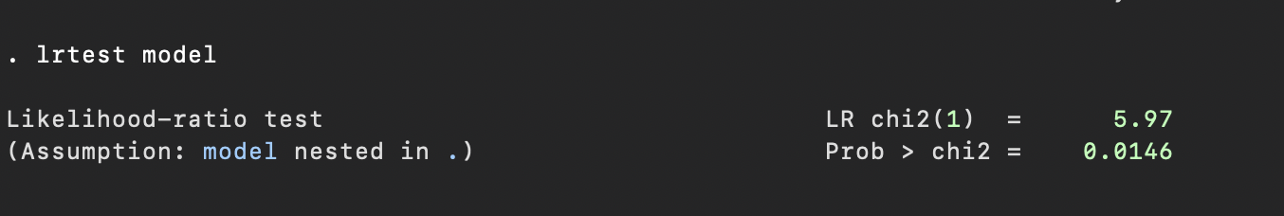

* 1. Provide a conclusion of no more than 3 sentences.

Likelihood ratio test comparing the models with and without the interaction shows statistically significant interaction between diabetes and cholesterol (p = .0146). The final model includes the interaction term diabetes * totchol.